How to covert an fzr600 shock to a R6 unit:
What you need:
06-08 R6 shock
Spacers
Dog bones

The Shock:
These can be picked up of eBay for ~$25USD. The lower shock mount needs to rounded so that it clears the suspension knuckle.
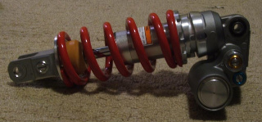
(Image 1) All the r6 shocks that can be used for this conversion look like this.

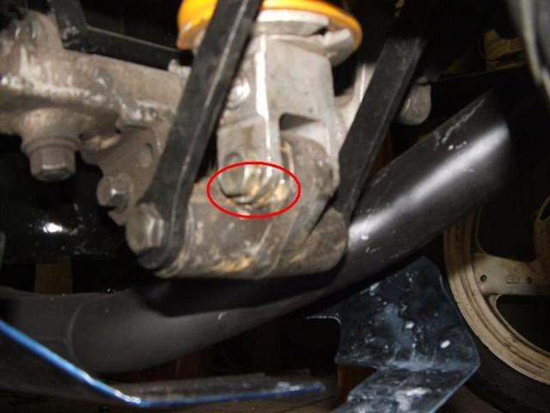
(Image 2) This is where you have to grind the shock slightly so it clears the suspension knuckle.
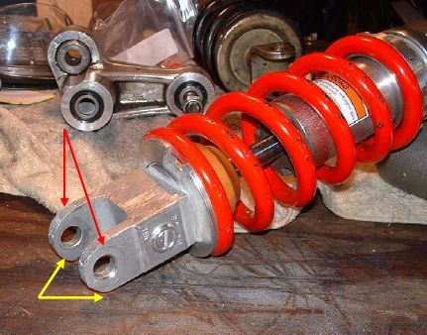
(Image 3)
The spacers:
Two of these spacers are required as the fzr600’s top shock mount is 10mm wider than the R6’s and uses a 12mm top mounting bolt opposed to a 10mm bolt. For the fzr400 ignore the stepped down section (red) as the fzr400 uses a 10mm bolt which is the same size as the R6, so you only need the green section.

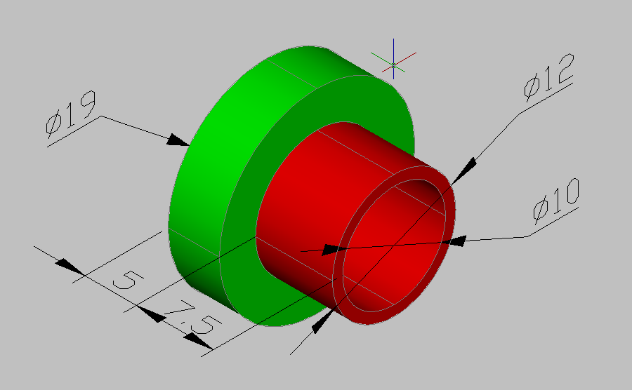
(Image 4)
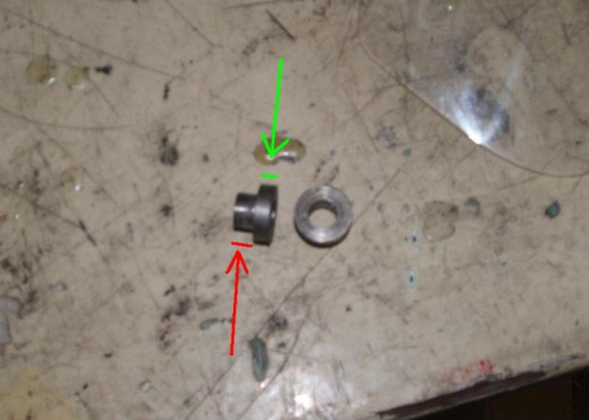
(Image 5)
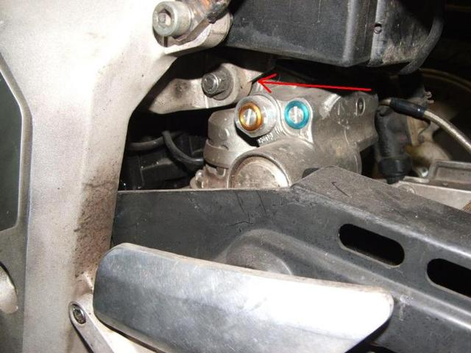
(Image 6) This is where the spacers go.
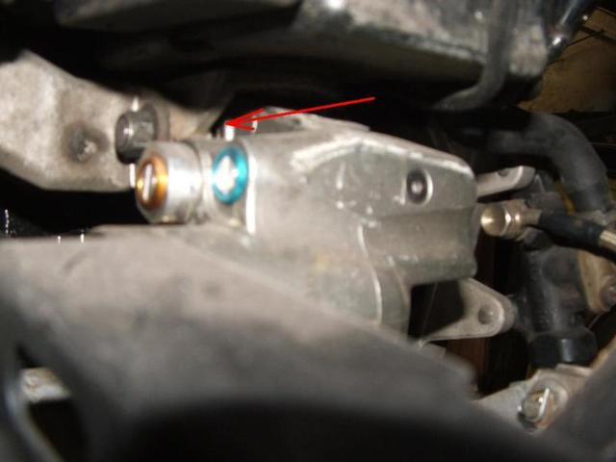
(Image 7)
Dog bones:
Approximately 10mm short than the FZR dog bones, these raise the bike back to near stock height. These are made from 6mm thick steel or similar tensile strength aluminium.
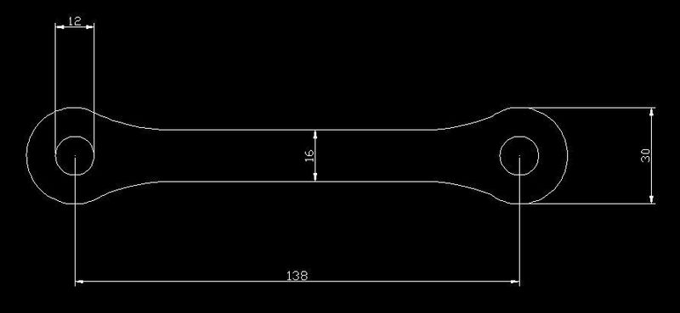(Image 8)

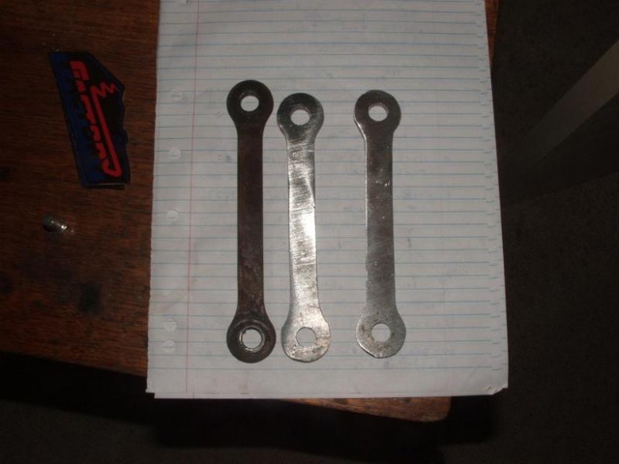
(Image 9) Stock dog bones on the left next to two new ones on the right.

Installation:
- Place the bike on suitable stands so that the rear of the bike is raised off the ground.
- Remove lower dog bone linkage bolt (bottom left of circle, image 2)
- Remove upper dog bone bolt and remove dog bones.
- Remove lower shock mount bolt (circled, image 2)
- Remove upper shock mount bolt (arrow image 6).
- Original shock can now be removed. (FZR400 3en1 see note below)
- Install spacers in the upper shock mount (image 7). Large diameter end faces inwards, towards shock.
- Insert R6 shock
- Reversal of steps 2 - 5 noting that the bolts should be torqued to 27lbs.

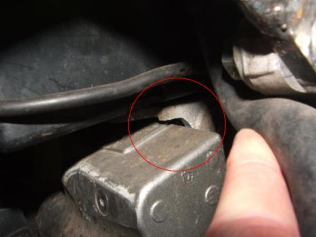
(Image 10)
Note: for the fzr400 (3en1) a small amount of the top frame mount has to be ground away. The Swingarm from the 3en1 would also require serious modification to work so either a 3en2 or 1wg must be used (I think from memory the chain guard needs to be slightly modified to fit). A 3tj swingarm could also probably be used but would require some modification to the swingarm pivot.

